Overview of Colonie
by Richard Sanders Allen
Colonie. What is it?
The stranger is hard-pressed to know, and even to the average Colonie resident the composition of the town is a minor mystery. It is "Colonie" when one crosses the Mohawk River on the north, or emerges from the capital city of Albany on the south. To the east a tiny portion of the town touches the Hudson River at the Menands Bridge leading to Troy, while to the west a long triangular finger of Colonie is practically in Schenectady.
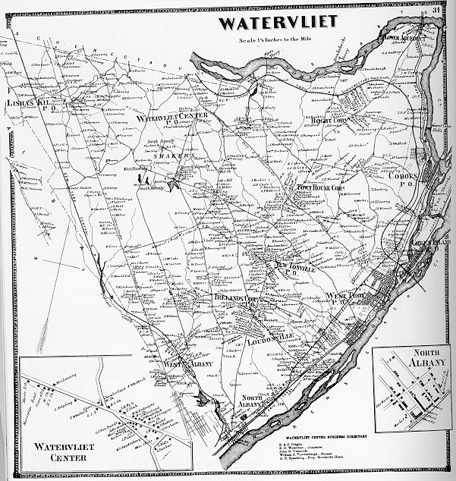
Perhaps the best way to picture Colonie is to see it from the viewpoint of an airline pilot leisurely jockeying his jet to line up with the approaches to Albany Airport. Colonie is the terrain below that is roughly bordered on the north and east b y the Mohawk and Hudson Rivers. One can visualize that down there extends everything but the built-up cities; all those one-time farms now dotted with housing developments; all those industries and small business interlaced with busy arterial highways; all that land comprising the northeast corner of Albany County - that is Colonie.
Facing Troy and Albany and Schenectady on three sides, and the recently developed Town of Clifton Park in Saratoga County across the river to the north, Colonie might well be called "The Tri-City Town," or termed: "The Hub of the Capital District." Strangely, Colonie is not the name of the post office, and never has been. The name is not, as you might suppose, an affectation of the English word "colony." Instead it is Dutch, and refers to the original "colonie" required by charter under the ancient Patroon system of land grants.
Roughly triangular, the Town of Colonie got its start as a political entity in 1791, but soon disappeared, gobbled up by its land- and tax-hungry neighbors. Most of the present-day Colonie comprised the old Town of Watervliet for three- quarters of a century.
The Hudson River was always an artery of commerce, dating back to the days of the Dutch traders. But, the Mohawk River proved to be a barrier on the north, and had to be crossed by various fords and ferries. What is now Colonie was part of the "pathway of Empire," the great north-south war route from New York to Canada, by which armies marched to battle in the French & Indian Wars and the American Revolution. Famous generals struggled to get troops and cannon, horses and baggage across the Mohawk at the sprouts of its delta below the awesome Cohoes Falls and above, at Loudon and Claus Ferries; using inadequate scows, or gingerly traversing the treacherous ice.
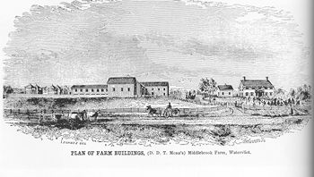
Colonie was for many years the breadbasket for Albany. The earliest Dutch farmers took the most fertile lands along the river-courses. Later, the westward-migrating New Englanders acquired the field and woods of central Colonie and by dint of clearing and fertilizing their farms began to supply the city folks in Albany with their daily grain, vegetable and dairy supplies.
Into this pastoral land came the Shakers, a vital presence in Colonie for well over a century. At first persecuted for their religious beliefs and way of life, the Shaker colonies with 3000 acres of farm land, mills and home-craft industries, were eventually accepted and looked upon as perhaps strange, but useful town citizens. In addition to Shaker industry, small shops employing neighborhood labor sprang up in Colonie. They made such things as agricultural implements, textiles, bolts and nuts, carriages, horse whips and brooms. One farmer was to specialize in celery-growing, a horticulturist nurtured new and beautiful plants and flowers, to meet a growing demand.
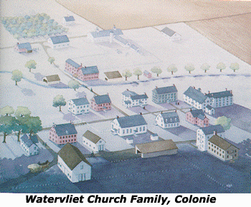
Along the western border of Colonie was another pathway to empire, the turnpike across the Pine Bush and its parallel "Shunpikes." These connected Albany on the Hudson River with Schenectady on the Mohawk, the jumping-off place for what was long called "The West." The main turnpike cut directly across the town; choked by dust in summer and rutted with mud and ice the rest of the year. It is difficult to imagine today that hundreds of stagecoaches and thousands upon thousands of wagons with droves of livestock passed this way with millions of people headed for new homes in Ohio, Michigan and beyond. Suffice to say that business came to Colonie through the media of closely spaced taverns set up along the route.
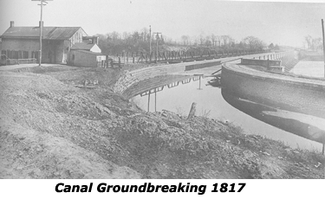
Much of this westward migration turned to the waterways when the Erie and Champlain Canals were dug along the borders of Colonie and opened in 1825. The horse-drawn packets came up from the Albany basin and the side-cut opposite Troy, and then began the arduous ascent, lock after lock up the hill past Cohoes. It sometimes took the better part of a day to gain the Mohawk Valley and go gliding over the broad stone aqueduct which arched the river at Crescent. It was a relaxing, leisurely way to travel, watching the straining horses, the labors of the locktenders, and listening to the boatman's refrain: "Low Bridge! Everybody Down!"
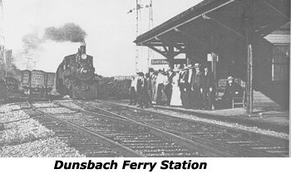
Erie Canal travel may have been idyllic, but it was slow. Though freight boats would ply the waterway through Colonie for ninety years, the travelers, caught up with a lust for speed, turned to the railroad. In 1831 New York State's first railroad, the Mohawk & Hudson, was built across the Pine plains through Colonie. The first trains were stagecoaches on flanged wheels and tugged along by the puffing little "De Witt Clinton" locomotive, rode across Colonie on wooden rails faced with iron strap and mounted on granite blocks. From this primitive beginning came rail travel on the once-mighty New York Central and its "smooth water-level" route to the West, followed by today's Amtrak.
Another form of transportation never envisioned by the Shaker farmers who tilled the land, was arrival and departure of people by means of the skies. Albany Airport, established in 1928, has grown from "that flying field up in Colonie" to a major international air terminal serving the entire Capital District and beyond. Thrifty Shaker ways and culture in the center of Colonie came to an end just as air transport came into being, and jet travel necessitated the take-over of much of the old carefully-nurtured Shaker farmland.
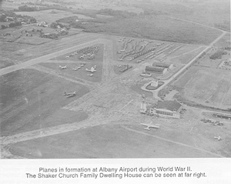
It might be said that Colonie slumbered for a century or more, content to be a crossroads of transportation and the provider of food for the adjacent capital city. Here and there the joys of country living tempted businessmen or well-to-do retirees to establish estates on the dirt roads and pleasant wooded acres to the north of Albany. It remained for the middle years of the present century to see the phenomenal growth of Colonie. From a population of 22,000 in 1938 it grew to over 60,000 in twenty years. Over 4,000 new homes were built in a single decade. With new residents came the need for ancillary businesses; stores and shopping centers; restaurants and auto services; distribution centers for products sold all over the northeast. The present population is approximately 80,000.
No longer "Albany's breadbasket", Colonie has become one of its most populous suburbs. Recent years have seen continued, but more stable and steady growth in the town, coupled with cultural advantages; new parks and recreational areas; improved schools; new churches and a fine library. With maturity has come a growing realization of the benefits to be derived from living in a self-contained political entity in which one can show some pride.
Historical awareness is of primary importance to this area.

